Week 2 – Assignment 1

1. Write a simple program in HTML that displays the heading “HTML defines the content and structure of your website” on the web browser

<!DOCTYPE html>

<html lang="en">

<head>

    <meta charset="UTF-8">

    <meta name="viewport" content="width=device-width, initial-scale=1.0">

    <title>Assignment-1</title>

</head>

<body>

    <h1>HTML defines the content and structure of your website</h1>

</body>

</html>

2. Explain the purpose of comments in HTML and provide an example of how to use comments in an HTML document.

* Comments are useful when we want to write something about the code, but we do not want to run that or show it in the output.
* Comments are basically for humans; we write comments for our future selves or for other developers who might work on the same codebase.
* Comments are not displayed in the web browser when you view the web page. They are only visible when you inspect the page's HTML source code

<!DOCTYPE html>

<html lang="en">

<head>

    <meta charset="UTF-8">

    <meta name="viewport" content="width=device-width, initial-scale=1.0">

    <title>Assignment-1</title>

</head>

<body>

    <!-- this is a single line comment -->

    <p>Lorem, ipsum dolor.</p>

    <!-- this is a multiline comment,

        In html the syntax to create both

         single and multi line comments are similar -->

    <p>Lorem ipsum dolor sit amet consectetur adipisicing elit.

        Recusandae possimus quasi aperiam consectetur dicta cum

        quas quod sequi repellendus rerum?</p>

</body>

</html>

3. Write an HTML program that includes a heading, a paragraph of text, a horizontal line and a line break. Arrange these elements to create a simple web page layout.

<!DOCTYPE html>

<html lang="en">

<head>

    <meta charset="UTF-8">

    <meta name="viewport" content="width=device-width, initial-scale=1.0">

    <title>Assignment-1</title>

</head>

<body>

    <h1>This is a heading</h1>

    <br>

    <p>This is a para</p>

    <hr>

</body>

</html>

Output:

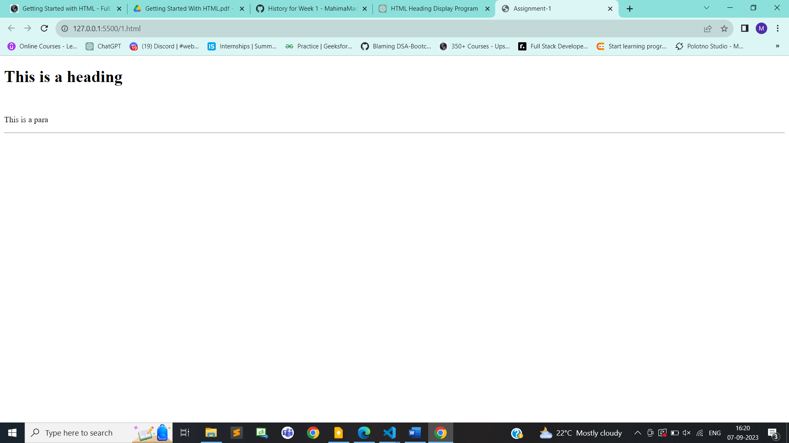

4. Write a short note on Tag and element with an example.

Both **tag** and **element** are fundamental concepts used to structure and define the content of a web page.

**HTML tag:**

* An HTML tag is composed of an opening tag and in some cases a closing tag.
* The opening tag starts with the less-than symbol (<). followed by the tag name, and ends with a greater-than symbol (>).
* The closing tag is similar but includes a forward slash (/) before the tag name.

**There are 2 types of tags in HTML:**

**1. Paired or container tags**  
Paired tags have both an opening and a closing tag and can contain other HTML elements and text within them.

Ex: <html></html>, <h1></h1> etc

**2. Singular tags**  
In HTML, some are self-closing tags or void tags because they don't require a separate closing tag.

Ex:<br/>, <img/> etc

**HTML element:**

An HTML element consists of an opening tag, content (which is the actual text or other elements), and a closing tag (in most cases).

Ex: <h1>This is a heading element</h1>

5. What is the DOCTYPE Declaration in HTML?

* The DOCTYPE Declaration in HTML (Document Type Declaration) is a special instruction placed at the very beginning of an HTML document to specify the type of HTML or markup language used in that document.
* Its primary purpose is to inform web browsers and validators about the version of HTML being used
* It must appear only once, at the top of the page.
* The <DOCTYPE> declaration is not case sensitive
* <!DOCTYPE> is an SGML (Standard Generalized Markup Language) declaration that signals the document type definition.
* In HTML5, the DOCTYPE Declaration is simplified and consists of just <!DOCTYPE html>

html specifies the type of document being used, which in modern HTML documents means that you're using HTML5.